Module 2: Power BI – Data Modeling (Advanced)

1. What is Data Modeling in Power BI?
Data modeling is the process of connecting tables using relationships so Power BI can analyze data correctly.
A good data model:
- Improves report performance
- Makes analysis easier
- Reduces duplicate data
- Helps create accurate dashboards

2. Star Schema
A Star Schema is the most recommended data model in Power BI.
It has:
- One central Fact Table
- Multiple surrounding Dimension Tables
Structure
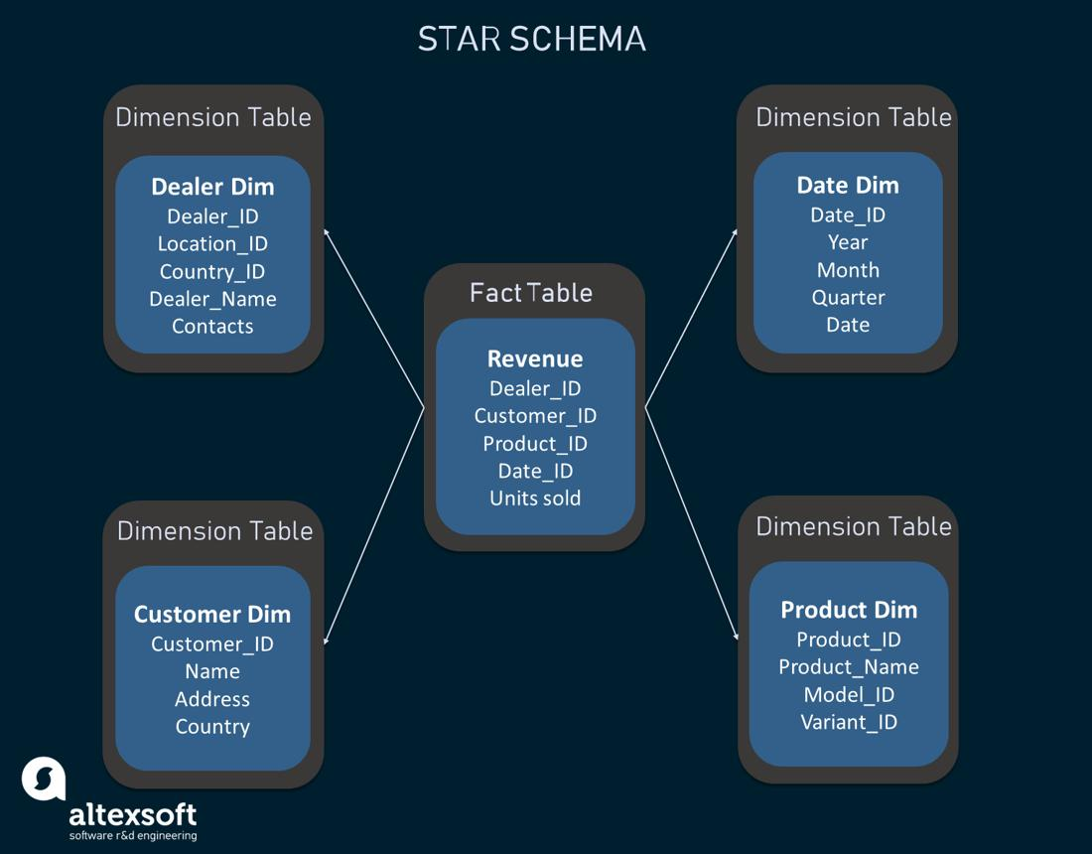
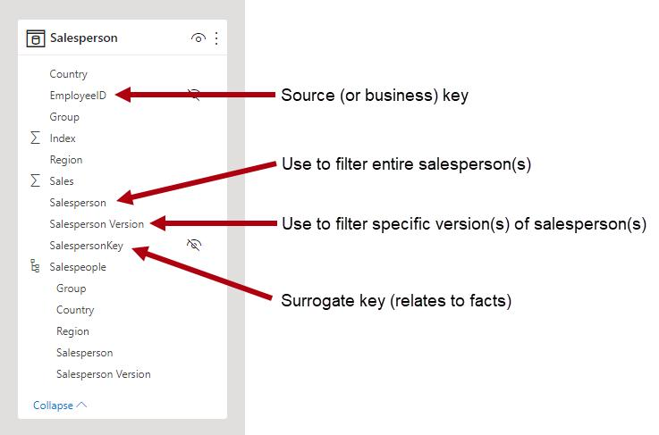
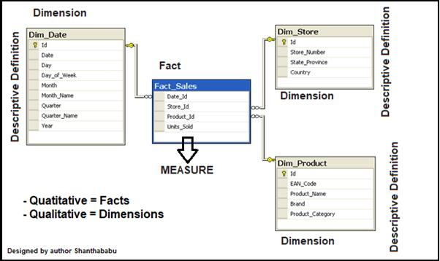
Example
Fact Table
Sales Table
- Order ID
- Product ID
- Customer ID
- Sales Amount
- Quantity
Dimension Tables
Product Table
- Product ID
- Product Name
- Category
Customer Table
- Customer ID
- Customer Name
- Region
Date Table
- Date
- Month
- Year

Advantages of Star Schema
✅ Faster performance
✅ Easy to understand
✅ Better for DAX calculations
✅ Recommended by Microsoft

Steps to Create Star Schema in Power BI
Step 1: Load Data
- Open Microsoft Power BI Desktop
- Click Home → Get Data
Step 2: Import Tables
Import:
- Sales
- Product
- Customer
- Date
Step 3: Open Model View
- Click Model View on left panel
Step 4: Create Relationships
Drag:
- Product ID → Product Table
- Customer ID → Customer Table
- Date → Date Table
Step 5: Verify Model
Fact table should be in center and dimensions around it.

3. Snowflake Schema
A Snowflake Schema is an extension of Star Schema where dimension tables are further divided into sub-dimension tables.
Structure
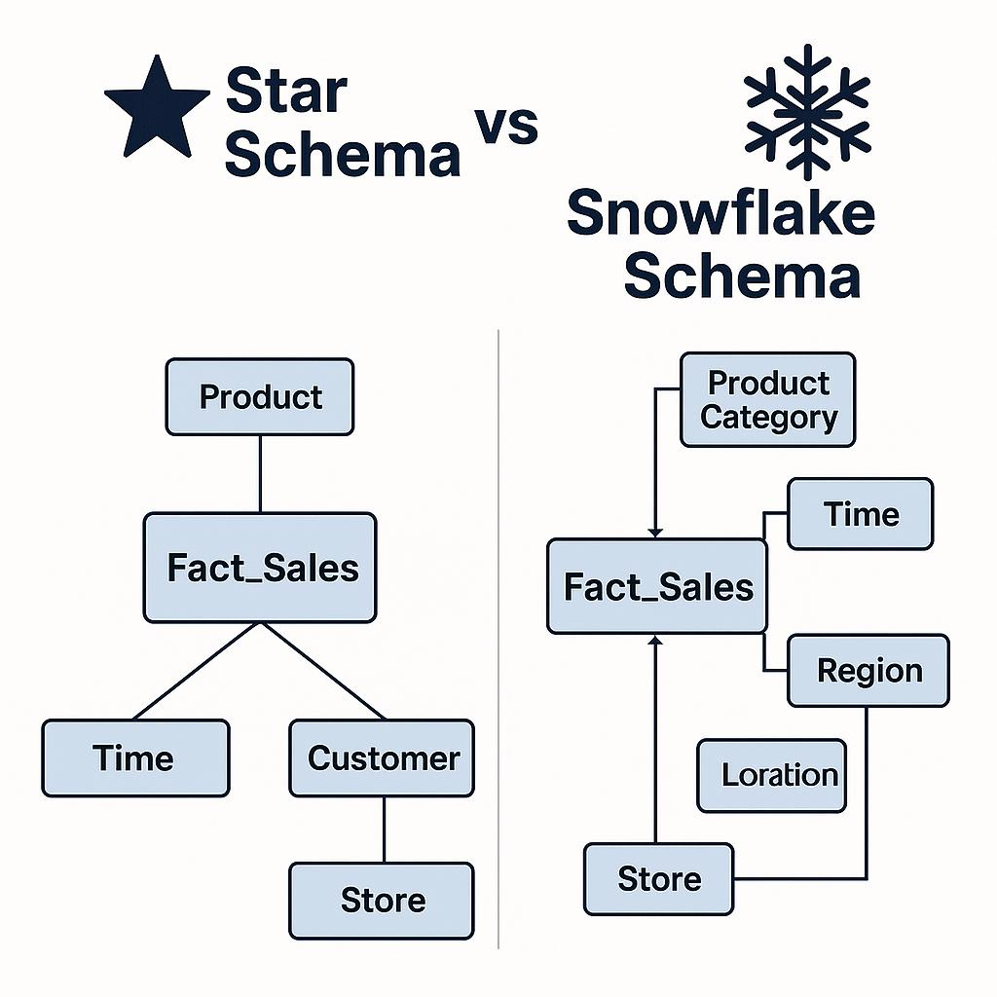

Snowflake Schema Structure
Fact_Sales
|
|---- Dim_Product ---- Dim_Subcategory ---- Dim_Category
| |
| ---- Dim_Brand
|
|---- Dim_Customer ---- Dim_City ---- Dim_State ---- Dim_Country
|
|---- Dim_Store
|
|---- Dim_Date

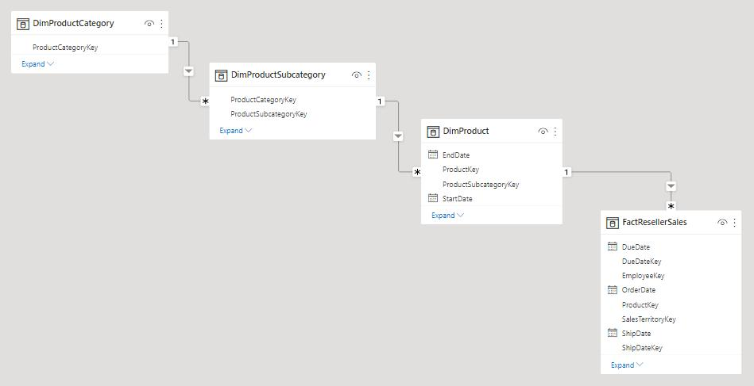
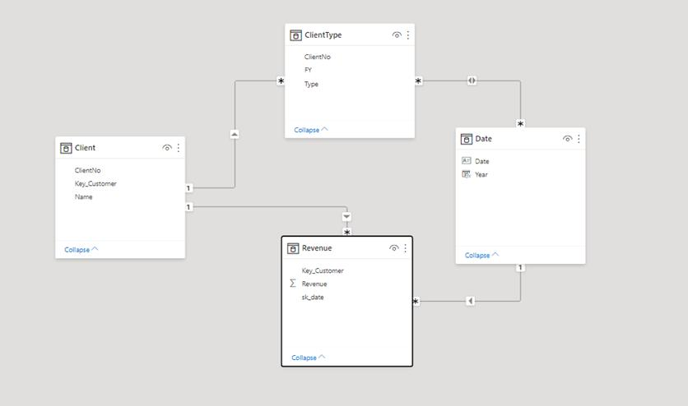

Example
Sales Fact Table connected to:
- Product Table
Product Table connected to:
- Category Table
- Supplier Table

Advantages
✅ Reduces data redundancy
✅ Better normalization
Disadvantages
❌ More complex
❌ Slower performance
❌ Harder to maintain

4. Star Schema vs Snowflake Schema
Feature | Star Schema | Snowflake Schema
Structure | Simple | Complex
Performance | Faster | Slower
Normalization | Low | High
Ease of Use | Easy | Moderate
Best For | Power BI reports | Large enterprise warehouses

5. Fact Table
A Fact Table contains measurable values.
Examples of Measures
- Sales
- Profit
- Quantity
- Discount
Characteristics
- Very large table
- Contains foreign keys
- Numeric data used in calculations

Example of Fact Table
Order ID | Product ID | Customer ID | Sales
1001 | P101 | C201 | 500
1002 | P102 | C202 | 700

6. Dimension Table
A Dimension Table contains descriptive information.
Examples
- Product Name
- Customer Name
- Region
- Category

Example of Dimension Table
Product ID | Product Name | Category
P101 | Laptop | Electronics
P102 | Chair | Furniture

7. Relationships in Power BI
Relationships connect tables together.
Types of Relationships

A. One-to-One (1:1)
One row in Table A connects to one row in Table B.
Example
Employee Table ↔ Employee Details
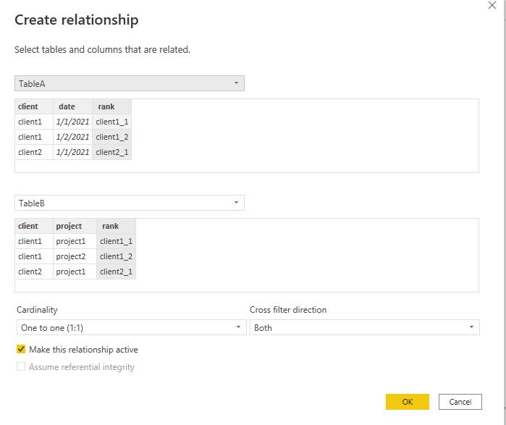
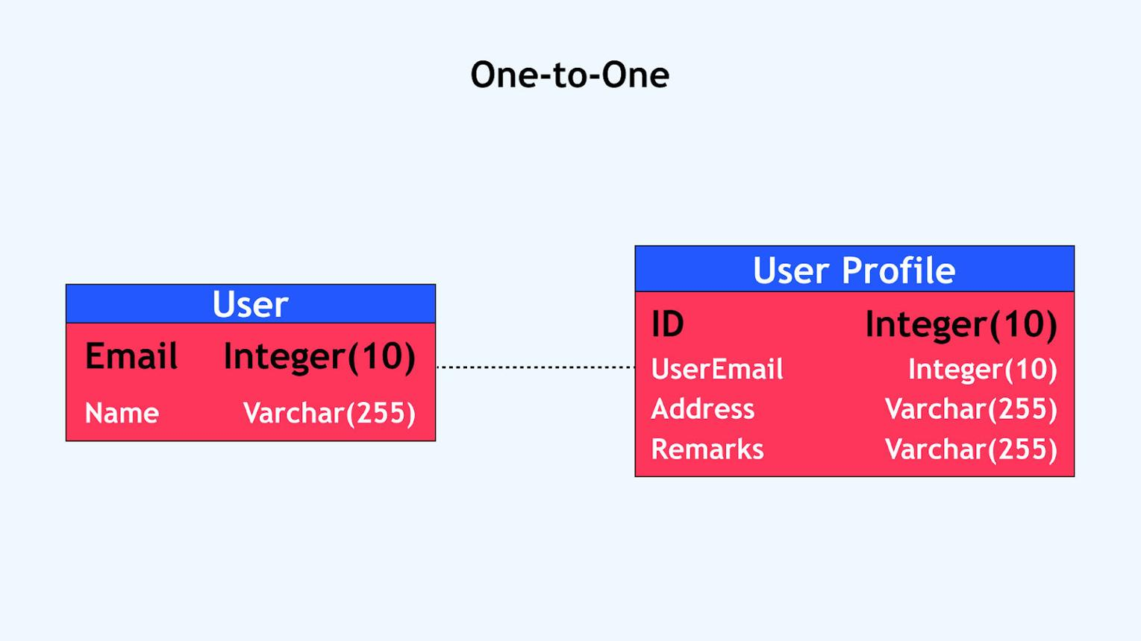
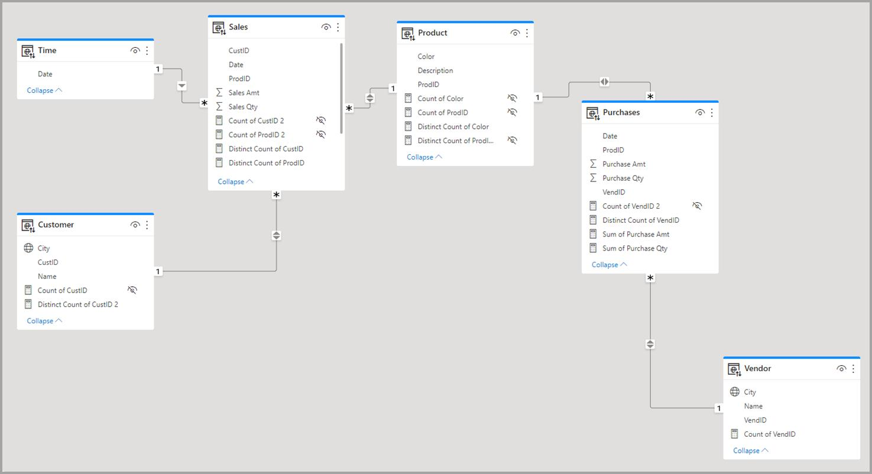

B. One-to-Many (1:M)
Most common relationship.
One record in Dimension Table connects to many records in Fact Table.
Example
One Product → Many Sales

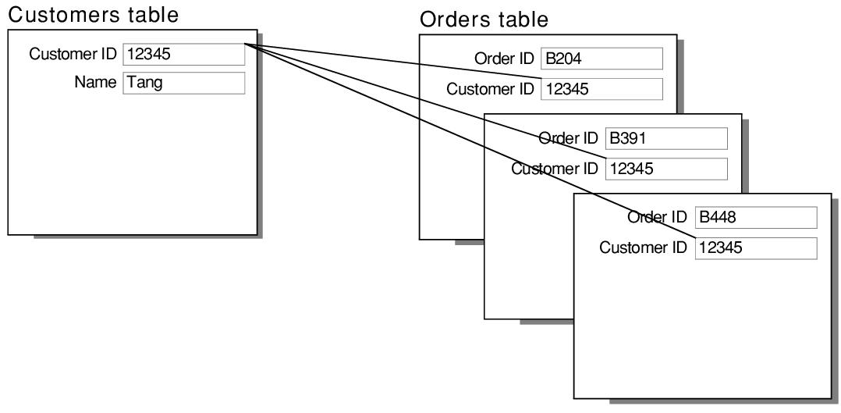
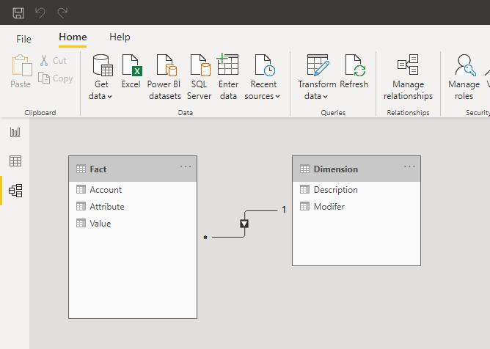

C. Many-to-Many (M:M)
Many records in both tables can connect.
Example
Students ↔ Courses
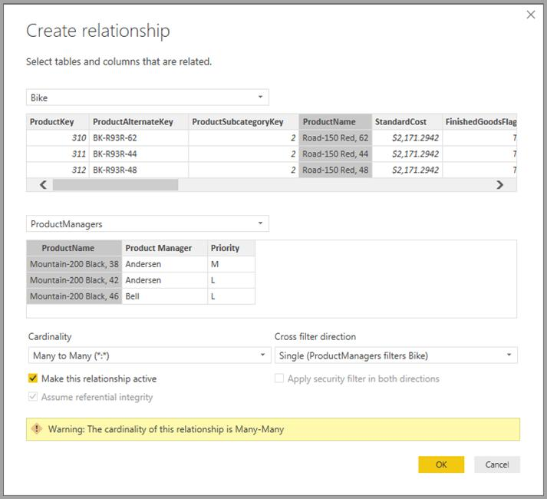


8. Steps to Create Relationships in Power BI
Method 1: Drag and Drop
Step 1
Open Model View
Step 2
Drag common field from one table to another.
Step 3
Relationship window opens.
Step 4
Choose:
- Cardinality
- Cross-filter direction
Step 5
Click OK

9. Cross-Filter Direction
Cross-filter direction controls how filtering works between tables.

A. Single Direction
Filter moves in one direction only.
Example:
Dimension → Fact
Recommended for most models.
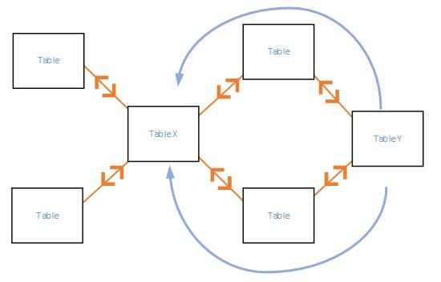

B. Both Direction
Filters move both ways between tables.
Used for:
- Many-to-many relationships
- Complex reporting
⚠ Avoid excessive use because it can slow performance.



10. Data Normalization Basics
Normalization means organizing data to reduce duplication.

First Normal Form (1NF)
- No duplicate columns
- Atomic values only

Second Normal Form (2NF)
- Remove partial dependency

Third Normal Form (3NF)
- Remove indirect dependency

Example
Before Normalization:
Order ID | Customer Name | City
101 | Amit | Delhi
102 | Amit | Delhi
After Normalization:
Customer Table:
Customer ID | Customer Name | City
C1 | Amit | Delhi
Orders Table:
Order ID | Customer ID
101 | C1
102 | C1

